DATA SCIENCE MINOR PROJECT REPORT
Subject: Data Science Toolbox: Python Programming
PROJECT REPORT
(Project Semester January-April 2025)

Smoke Signals: A Data-Driven Analysis of Active Tobacco Retailers in Texas

Submitted by
Rishav Kumar

Registration No: 12326151

Programme and Section: Computer Science & Engineering
Course Code: INT375

Under the Guidance of

DR. Manpreet Singh Sehgal

Discipline of CSE/IT

Lovely School of Computer Science

Lovely Professional University, Phagwara

CERTIFICATE

This is to certify that Rishav Kumar bearing Registration no. 12326151 has completed INT375 project titled, “Smoke Signals: A Data-Driven Analysis of Active Tobacco Retailers in Texas” under my guidance and supervision. To the best of my knowledge, the present work is the result of his/her original development, effort and study.

Signature and Name of the Supervisor
Designation of the Supervisor
School of Computer Science
Lovely Professional University
Phagwara, Punjab.

Date: 12.04.2025

DECLARATION

I, Rishav Kumar, student of B.Tech under CSE/IT Discipline at, Lovely Professional University, Punjab, hereby declare that all the information furnished in this project report is based on my own intensive work and is genuine.

Date: 12.04.2025 Signature
Registration No.: 12326151 Rishav Kumar

Table of Content

Introduction

Dataset Overview

Data Analysis Objectives & Results

Key Insights

Conclusion

Tools

Reference

1. Introduction
The goal of this project was to perform exploratory data analysis on a dataset containing information about active tobacco and cigarette retailers operating primarily in Texas. By analyzing this dataset, we aimed to uncover patterns, trends, and insights related to the types of permits issued, retailer distribution by location, and licensing trends over time.
The analysis was conducted using Python with libraries such as Pandas for data manipulation and Seaborn and Matplotlib for data visualization. This project not only strengthened my understanding of real-world data analysis but also provided hands-on experience in transforming raw data into meaningful insights.

2. Dataset Overview
The dataset, titled “Active_Cigarette_Tobacco_Retailers.csv”, was sourced from public records and includes information about 59,401 active tobacco retail permits in Texas. The dataset contains 14 fields, including:
- id: Unique identifier for each entry
- Taxpayer ID & Name: Identifies the business owner or operating entity
- Location Name & Address: Specifies the store or retailer's physical presence
- City, County, State, Zip Code, Zip+4: Location-specific information
- Permit Type: Type of license issued (e.g., E-CIG RETAILER, CIG/TOB RETAILER)
- Permit Number: Unique permit identifier
- Permit Begin Date: Start date of the permit's validity
Although the dataset is relatively clean and complete, minor issues such as missing values in Zip+4 and Permit Number fields were observed. The data is current as of the time of extraction and exclusively represents retailers operating in the state of Texas.

3. Data Analysis Objectives & Results

Objective 1: Number of Retailers by Permit Type
A bar plot was created to show the distribution of permit types. The majority of businesses fell under two main categories: “CIG/TOB RETAILER” and “E-CIG RETAILER.” This analysis provides insight into the balance between traditional tobacco and newer electronic cigarette vendors across Texas.
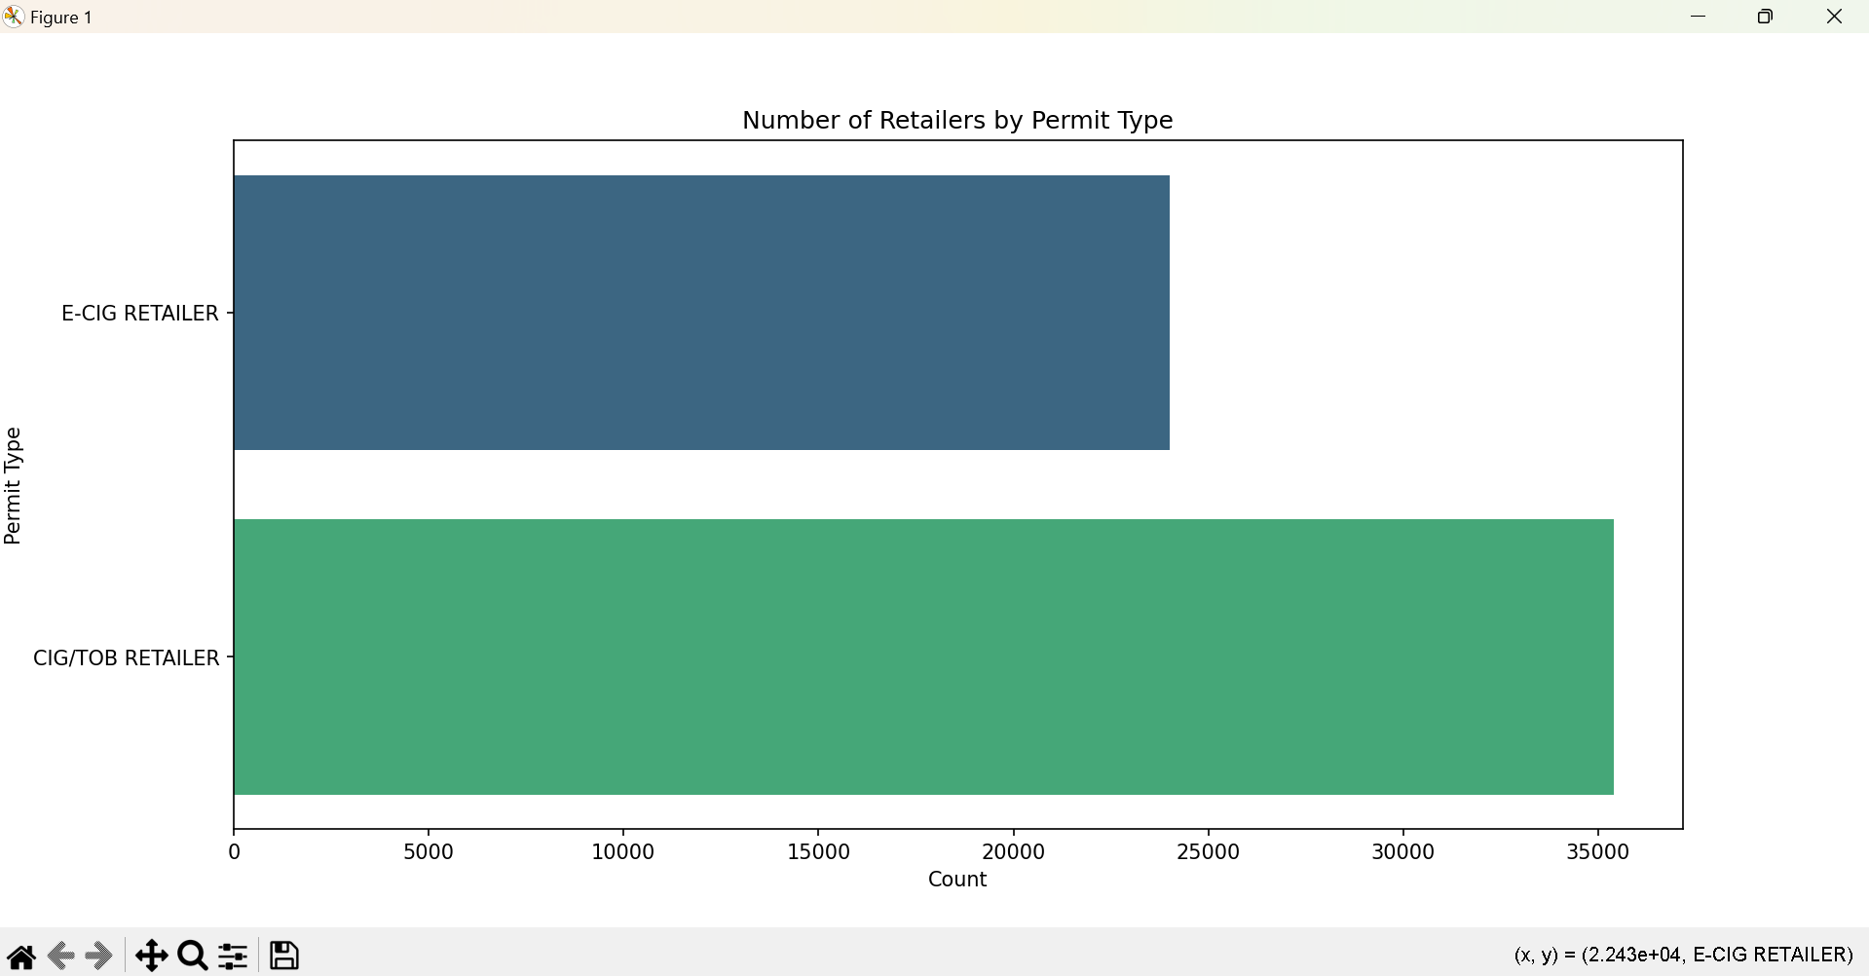

Objective 2: Top 10 Cities with the Highest Number of Retailers
By aggregating the dataset by the ‘City’ column, I was able to identify urban centers with the most active tobacco retailers. Houston, Dallas, and San Antonio ranked highest, suggesting that tobacco retailing is significantly concentrated in large population centers.
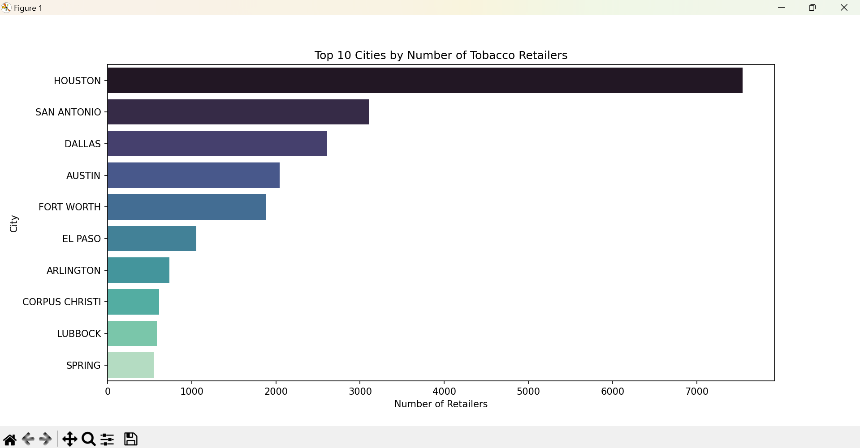

Objective 3: Year-wise Permit Issuance Trend
Using the ‘Permit Begin Date’, I extracted the year of issuance for each permit and created a time series line plot. The data revealed peaks in certain years, indicating periods of growth or regulatory change that may have influenced licensing behavior.
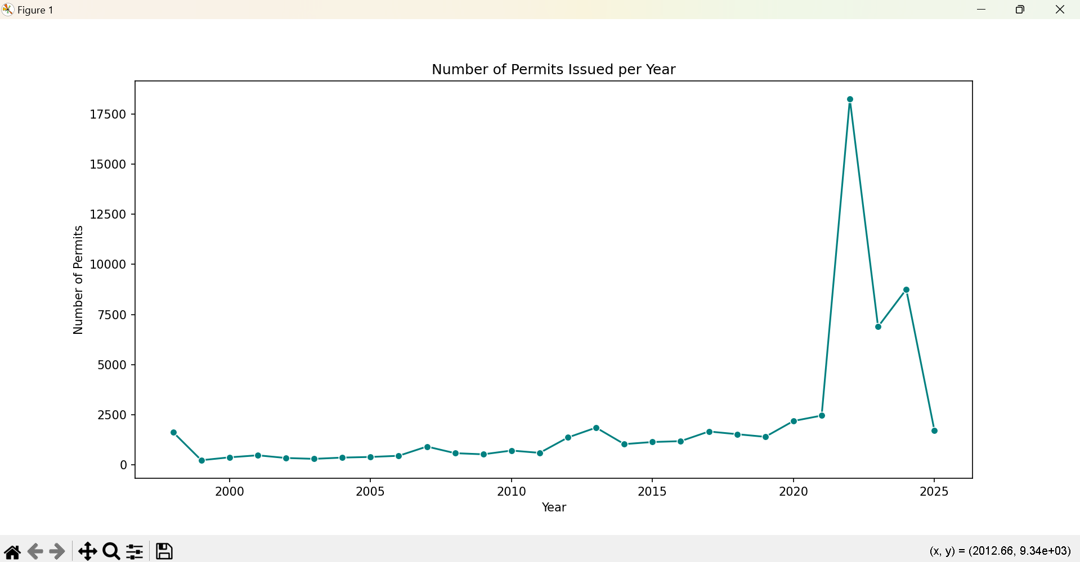

Objective 4: Retailers by County (Top 10)
A similar aggregation was done at the county level, revealing Harris, Dallas, and Bexar as the counties with the highest retailer count. These results complement the city-wise findings and reinforce the role of metropolitan areas in tobacco retailing.
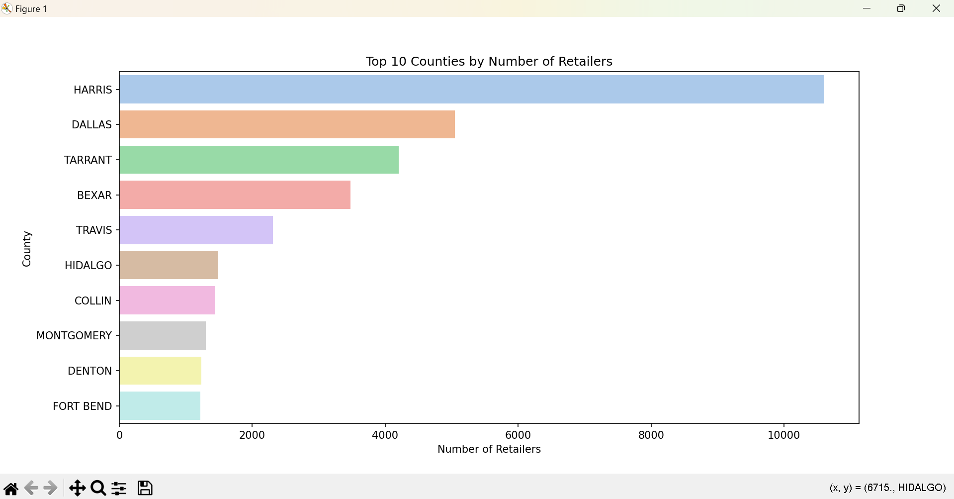

Objective 5: Proportion of Retailers by Permit Type (Pie Chart)
In addition to visualizing permit types with a bar plot, I created a pie chart to show the proportional distribution of permit types among all active retailers. This visualization clearly illustrates the relative market share held by each type of tobacco permit. The chart showed that traditional tobacco retailers (CIG/TOB RETAILER) make up a significant portion of the dataset, followed by E-CIG RETAILER permits. This makes it easy to communicate the composition of the retailer landscape at a glance and supports the broader analysis of consumer trends in tobacco usage.
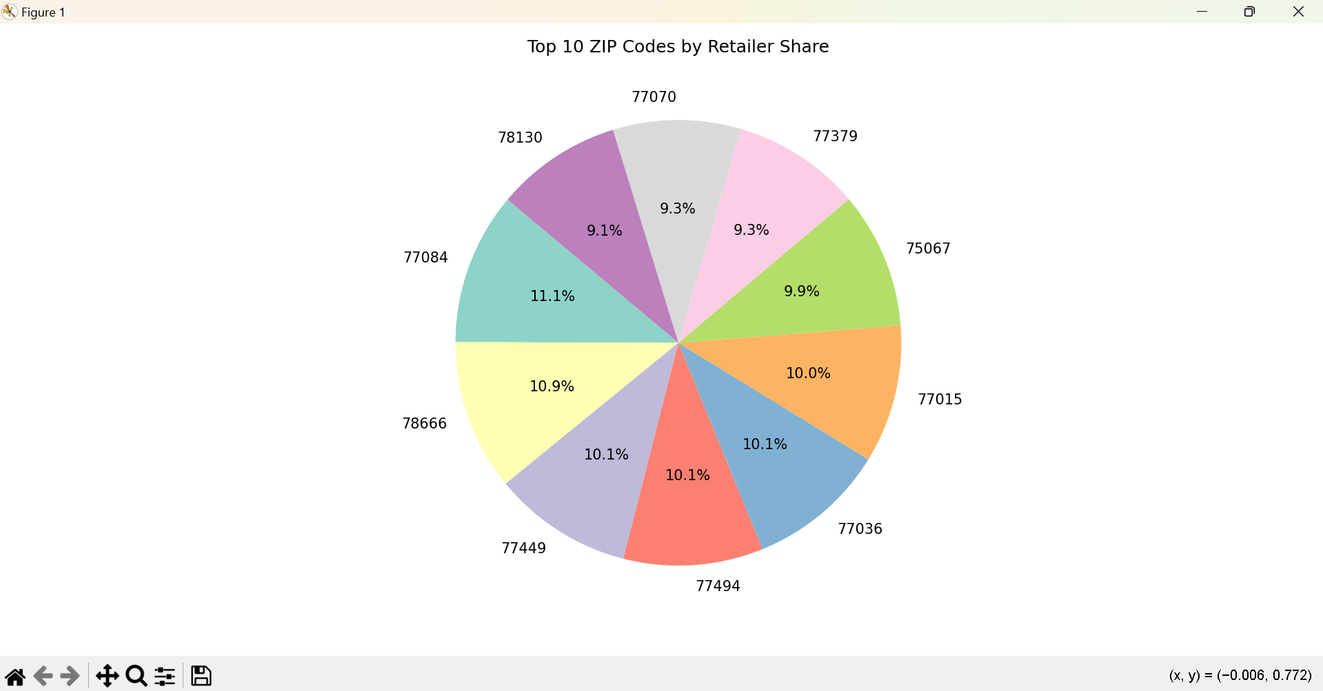

4. Key Insights
Through the analysis of 59,000+ active tobacco retail permits in Texas, several critical insights were drawn that highlight business trends, geographic concentration, and potential implications for policy and public health. These findings provide a foundation for further exploration into how tobacco products are regulated and consumed at the local level.
- Traditional Tobacco Still Dominates, But E-Cig Retailers Are Growing
Despite the increasing popularity of electronic cigarettes and vape products, traditional cigarette and tobacco retailers (CIG/TOB RETAILER) still make up a substantial portion of the market. However, the growing number of E-CIG RETAILER permits suggests a shift in consumer preferences and business strategies. This trend may continue as regulations and public awareness around vaping evolve.
- Retailer Concentration is Heavily Urban-Centric
Cities like Houston, Dallas, and San Antonio stand out as key hubs for tobacco retail activity. These urban centers not only have high population densities but also likely have more commercial real estate opportunities and customer bases that support such businesses. This indicates that retail permits are issued more frequently in economically active and densely populated areas.
- Permit Activity Varies Over Time — Reflecting Regulatory or Market Trends
The time-series analysis of permit issuance showed fluctuations over the years. Some years experienced spikes in new permits, which may align with changes in state laws, public health campaigns, or shifts in consumer demand. Observing these temporal trends can help forecast future licensing behavior and identify policy impacts.
- Certain Counties Dominate the Retail Landscape
Harris County (which includes Houston), Dallas County, and Bexar County were among the top counties with the highest concentration of retailers. These counties not only reflect economic powerhouses within the state but also suggest where public health efforts or zoning laws might need more focus to address youth access or market saturation.
- Visualizations Aid in Understanding Retail Permit Landscape
The pie chart summarizing permit type proportions and the bar charts comparing city and county-wise distributions helped to distill complex data into intuitive visuals. These charts made it easier to identify outliers, patterns, and imbalances in the data, which could be particularly helpful for policy makers, business analysts, or health researchers.

5.Conclusion

This project provided a comprehensive exploration of the landscape of active cigarette and tobacco retailers in the state of Texas. By analyzing over 59,000 permit records, I was able to uncover meaningful patterns related to business types, geographic concentration, and the evolution of retailer licenses over time. Through visualizations and aggregation techniques, the raw data was transformed into clear insights that could serve a range of audiences—from public health officials to urban planners and business strategists.
One of the most significant takeaways is the continued dominance of traditional cigarette and tobacco retail businesses, despite the rapid rise of e-cigarette retailers. This dual presence suggests that while the market is evolving, legacy habits and products remain deeply entrenched in Texas communities. The concentration of permits in highly urbanized counties and cities further illustrates how tobacco sales remain tied to population density and commercial opportunity.
The temporal analysis revealed interesting trends in licensing activity, potentially shaped by state legislation, changing consumer preferences, or even economic events. These fluctuations highlight the importance of ongoing monitoring and data-driven decision-making in managing tobacco-related commerce and its public health implications.
From a technical perspective, this project enhanced my skills in data cleaning, grouping, and visualization using Python libraries like Pandas, Matplotlib, and Seaborn. It also emphasized the importance of context—understanding that behind every data point is a real-world entity that can influence or be influenced by broader social and economic factors.
In conclusion, this analysis not only deepened my understanding of tobacco retail activity in Texas but also demonstrated the power of data analytics in uncovering trends that are not immediately visible from raw data. It is a strong reminder that effective data storytelling can turn complex datasets into actionable knowledge that supports smarter decision-making in business, policy, and public health domains.

6.Tools
- PYTHON IDLE (Python 3.13 64-bit)
- VS CODE

7.Referance

- BlackBox.ai

8.Dataset Download Link

https://data.texas.gov/views/n4rp-ar9b/rows.csv?accessType=DOWNLOAD

